# Eastern Goldfields College Year 12 2017

# Mathematical Methods Investigation 3

In-Class Section

**NORMAL DARTBOARDS**

Name:

DATE: Monday 24th July 2017

TIME ALLOCATED: 55 Minutes

A game developer is experimenting with different dart board shapes. She is looking at

certain dartboard designs and is considering the chance of hitting certain parts of the board.

In each problem the area of certain sections can be calculated using calculus or by using geometrical shape rules.

Assume the dart always hits the board in these problems.

***1. [6, 6 = 12 marks]***

Fill in the information for the following two dartboards using any method.

|  |  |
| --- | --- |
| Dartboard 1 | Sketch |
|  |  |

|  |  |
| --- | --- |
| Dartboard 2 | Sketch |
| (to 4 d.p.) | (to 4 d.p.) |

1. ***[1, 2 = 3 marks]***

Find the value of k such that the area of each of these dartboards is equal to 1.

a) Dartboard 3: 

b) Dartboard 4: 

1. ***[1, 4 = 5 marks]***

The median (average) score for a dartboard is defined as the value on the x axis such that the area to the left of the score is equal to the area of the right of the score.

1. What is the area cutting off the median value for a board with an area of 1?

1. Find the median score for each of the two boards, Dartboard 3 and Dartboard 4.

Show working where necessary.

1. ***[1,4 = 5 marks]***

A dartboard is defined by y =  for 1 ≤ x ≤ k.

1. Write an integral that could be solved to find the value

of k to make the area of the dartboard equal to 1.

1. Solve your integral using calculus to determine the exact value of k for part a.

You can use your calculator but must indicate each step to obtain full marks.

**Background information for this part of the Investigation.**

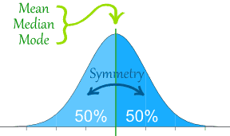The “bell shaped” Normal curve is a

very common distribution.

|  |  |
| --- | --- |
| The Normal Distribution has:   * [mean](http://www.mathsisfun.com/mean.html) = [median](http://www.mathsisfun.com/median.html) = [mode](http://www.mathsisfun.com/mode.html) * symmetry about the centre * http://www.mathsisfun.com/data/images/normal-distrubution-3sds.gif50% of values less than the mean  and 50% greater than the mean |  |
|  | 68% of values are within 1 standard deviation of the mean          95% are within 2 standard deviations          99.7% are within 3 standard deviations |

***5. [2 marks]***

The Fresha Tea Company pack tea in bags marked as 250 g

A large number of packs of tea were weighed and the mean and standard deviation were calculated as 255 g and 2.5 g respectively.

Assuming this data is normally distributed, what percentage of packs are underweight?

A 2.5% B 3.5% C 5% D 16%

Refer to previous page for assistance.

***6. [1,1 = 2 marks]***

A school exam results that are **normally** distributed.

Given that 99.7% of the exam scores are between 38% and 92% find

(a) the mean score

1. the standard deviation

***7. [3,2,2,2,2 = 11 marks]***

Shown below are the results of the 40 student’s results at a school in an ATAR Mathematics, together with the mean and standard deviation.

|  |  |  |  |  |  |  |  |
| --- | --- | --- | --- | --- | --- | --- | --- |
| 52 | 72 | 56 | 77 | 59 | 55 | 67 | 52 |
| 50 | 84 | 85 | 53 | 75 | 81 | 49 | 47 |
| 77 | 70 | 71 | 63 | 60 | 78 | 40 | 40 |
| 71 | 61 | 63 | 54 | 64 | 59 | 52 | 86 |
| 57 | 49 | 76 | 68 | 65 | 64 | 64 | 98 |

 and 

1. Determine the percentage of exam scores within 1 standard deviation of the mean.
2. Compare this with the expected percentage if the distribution is normally distributed.

Comment on how closely the distribution fits with the Normal Distribution.

1. Determine how many standard deviations above the mean is the student who got 81% for the exam.
2. Any student who is more than 0.9 standard deviations above the mean will receive an A grade. Determine the number of A grades, justifying your answer.
3. Assume the results for all students in the state for this ATAR mathematics exam is Normally Distributed with a mean of 64 and a standard deviation of 12. What percentage of students would you expect to get 76% or higher?

***8. [3,2 = 5marks]***

The heights of male students at high schools are Normally Distributed with mean 1.7 m and standard deviation 0.2 m

Show working to justify each question below.  
  
You may use this Standard Normal Distribution curve below to help or you may choose a calculator method.

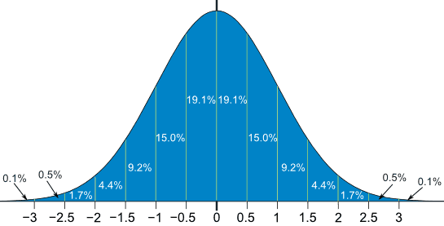

a) In a population of 5000 male high school students, how many would you expect to have a

height between 140 cm and 190 cm?

b) What height would expect the 5th tallest student to be close to?

END OF INVESTIGATION